

**Department of Computer Science and Engineering**

**Programme Name: B.Tech in Computer Science and Engineering (AI)**

**Semester V**

**Course Name: Computer Networks Lab**

**Course Code: PCC-CSM592**

**Experiment 7**

**Aim:** Examining NAT protocol.

**Network address translation** (**NAT**) is a method of mapping an IP [address space](https://en.wikipedia.org/wiki/Address_space) into another by modifying [network address](https://en.wikipedia.org/wiki/Network_address) information in the [IP header](https://en.wikipedia.org/wiki/IP_header) of packets while they are in transit across a traffic [routing device](https://en.wikipedia.org/wiki/Router_(computing)). The technique was originally used to bypass the need to assign a new address to every host when a network was moved, or when the upstream [Internet service provider](https://en.wikipedia.org/wiki/Internet_service_provider) was replaced, but could not route the network's address space. It has become a popular and essential tool in conserving global address space in the face of [IPv4 address exhaustion](https://en.wikipedia.org/wiki/IPv4_address_exhaustion). One Internet-routable [IP address](https://en.wikipedia.org/wiki/IP_address) of a NAT gateway can be used for an entire [private network](https://en.wikipedia.org/wiki/Private_network).

|  |  |  |  |
| --- | --- | --- | --- |
| S.No. | Device | Model Name | Qty. |
| 1. | PC | - | 2 |
| 2. | Server | Server-PT | 1 |
| 2. | switch | Switch-PT | 2 |
| 3. | router |  | 2 |

|  |  |  |  |
| --- | --- | --- | --- |
| S. No. | Device | IPv4 Address | Device Gateway |
| 1 | PC1 | 10.10.10.2 | 10.10.10.1 |
| 2 | Server1 | 10.10.10.3 | 10.10.10.1 |
| 2 | PC2 | 20.20.20.2 | 20.20.20.1 |

|  |  |  |  |
| --- | --- | --- | --- |
| S. No. | Device | Interface | IPv4 Address |
| 1 | Router0  (Router-PT) | FastEthernate0/0 | 10.10.10.1 |
| Serial2/0 | 192.162.10.1 |
| 2 | Router2  (Router-PT) | FastEthernate0/0 | 20.0.0.1 |
| Serial2/0 | 192.162.10.2 |

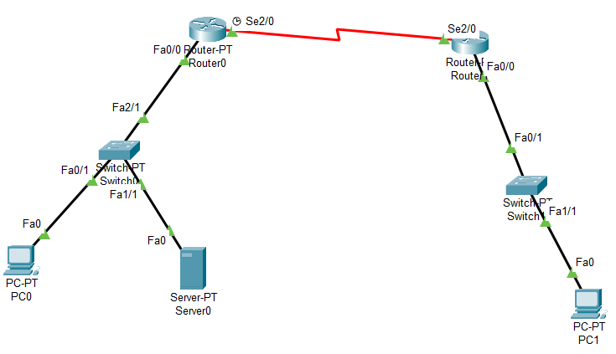

**CLI command for Router0:**

Router(config-if)#exit

Router(config)#ip nat inside source static 10.10.10.2 50.50.50.2

Router(config-router)# ip nat inside source static 10.10.10.3 50.50.50.3

Router(config-router)#interface fastEthernet 0/0

Router(config-router)#ip nat inside

Router(config-router)#exit

Router(config)#interface serial 2/0

Router(config-router)#ip nat outside

Router(config-router)#exit

**CLI command for Router1:**

Router(config-if)#exit

Router(config)#ip nat inside source static 20.20.20.2 60.60.60.2

Router(config-router)#interface fastEthernet 0/0

Router(config-router)#ip nat inside

Router(config-router)#exit

Router(config)#interface serial 2/0

Router(config-router)#ip nat outside

Router(config-router)#exit

**CLI command for Router0:**

:Router(config-if)#exit

Router(config)#ip route 60.0.0.0 255.0.0.0 192.162.10.2

Router(config-router)# exit

**CLI command for Router1:**

:Router(config-if)#exit

Router(config)#ip route 50.0.0.0 255.0.0.0 192.162.10.1

Router(config-router)# exit

Router#show ip route

Ping in command prompt

Output: